Jenny Anger

Grinnell College

624 S. Summit St.

Iowa City, IA  52240

[ANGER@grinnell.edu](mailto:ANGER@grinnell.edu)

***Société Anonyme* Word Count: 494**

The *Société Anonyme, Inc., Museum of Modern Art, 1920*, was an international, avant-garde exhibiting society from 1920 to 1950. Founded in New York by Katherine Dreier, Marcel Duchamp, and Man Ray, the *Société* sought to educate America about modern art. During its existence, the *Société* organised some eighty-five exhibitions, eighty-five public programs, and thirty publications. Primarily educational, the *Société* did not sell art, although it introduced interested parties. The *Société Anonyme* granted several premiere modernists their first American solo exhibitions, including Alexander Archipenko (1921), Wassily Kandinsky (1923), Paul Klee (1924), and Fernand Léger (1925). The *Société* modeled itself on Berlin’s *Der Sturm* gallery. From 1920 to 1924, the *Société* managed its own site; thereafter, it borrowed or rented venues, from women’s clubs to the Brooklyn Museum. In 1926, the latter hosted the *Société’s* monumental *International Exhibition of Modern Art,* which included 307 works from 23 countries. Advisers included Léger in Paris, Kandinsky in Dessau, and Kurt and Helma Schwitters in Hannover. The show is significant for its inclusive definition of ‘modern art’ (Cubism, Expressionism, Dada, and Constructivism were represented) and its unique installation (staged, domestic ‘rooms’ decorated with modern art were interspersed between more conventional galleries). Although praise arrived from as far away as Moscow—El Lissitsky wrote that he would exhibit in America only with the *Société Anonyme*—the exhibition’s long-term influence was curiously modest.

Dreier and Duchamp had met in 1917, when Dreier had sided with the board of the Society of Independent Artists to reject Duchamp’s *Fountain* (1917) for its annual New York exhibition. Eager to understand the infamous ‘readymade’ though, Dreier pressed Duchamp to explain his submission, and a rare friendship ensued. Man Ray did little more than suggest the name, which he had mistakenly translated literally. Duchamp explained that ‘Société Anonyme’ means ‘Incorporated’ in French. The three embraced the Dadaist *double entendre*, which the incorporation bureau doubled again by adding ‘Inc.’ to its name. The appendage, ‘Museum of Modern Art,’ signifies the unrealised goal to establish a museum of modern art in the U.S.

From the 1930s through World War II, the *Société* reduced its activities. Yet its international networks remained viable. Schwitters, for one, received spiritual and material sustenance from Dreier during his exile in Norway and the U.K. A museum to house the *Société Anonyme’s* collection (ca. 3000 works) never materialised, but a significant portion survives as a bequest to the Yale University Art Gallery. Friend and adviser to the end, Duchamp managed Dreier’s estate after her death in 1952.

**References and further reading:**

Anger, J. (2012) ‘*Der Sturm*, the *Société Anonyme*, and Modern Art in America’, *Der Sturm. Zentrum der Avantgarde*, vol. 2, (ed.) A. Birthälmer, A. von Huelsen-Esch, and G. Finckh, Wuppertal: von der Heydt-Museum: 543-70.

Gross, J. (ed.) (2006) *The Société Anonyme: Modernism for America*, New Haven: Yale University Press. <http://media.artgallery.yale.edu/socanon/>

Herbert, R., E. Apter, and E. Kenney. (eds.) (1984) *The Société Anonyme and the Dreier Bequest at Yale University: A Catalogue Raisonné*, New Haven: Yale University Press.

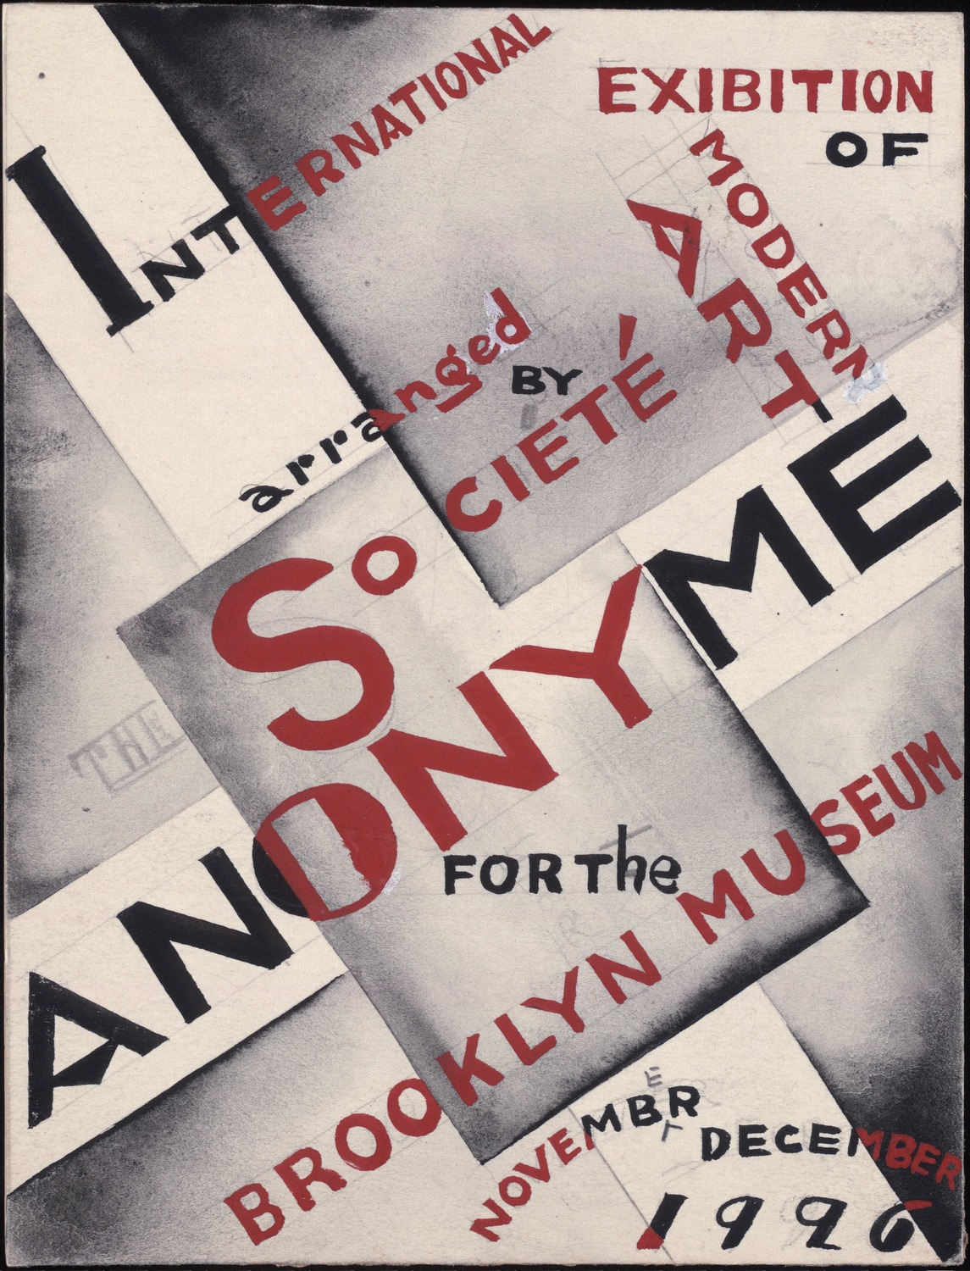

International Exhibition of Modern Art (1926-1927: Brooklyn Museum) catalog cover, pencil and paint drawing

From: Katherine S. Dreier papers / Société Anonyme archive

<http://brbl-dl.library.yale.edu/vufind/Record/3520542>